Doctrine of Baptism Seminar

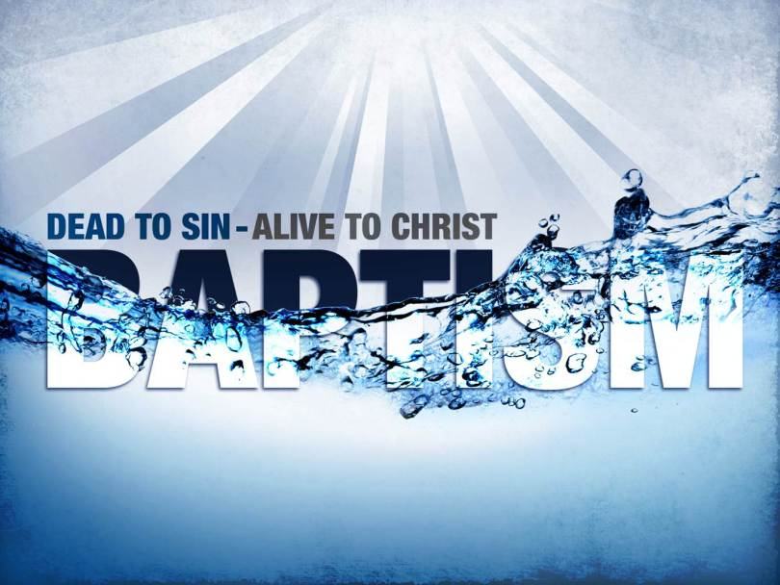

The Apologetic Research Society will be hosting a 10 hour weekend seminar on the Doctrine of Baptism taught by Dr. Jack Cottrell Professor of Theology at Cincinnati Christian University (a Restoration Movement School) and author of several books such as Baptism: A Biblical Study.

When: Friday, September 16th from 6:00pm to 9:30 p.m. and Saturday, September 17th from 9:00 a.m. to 5:00pm.

Where: The Metro Los Angeles Church of Christ located at: 15610 Crenshaw Blvd. Gardena, CA 90249.

Cost: $25

Registration: Contact Jan Oakes at joakes01@san.rr.com or at 858-505-8841 You can simply let her know you are definitely coming and pay at the door or you can pay ahead of time.
Synopsis: The purpose of this seminar will be to explain what the Bible teaches about the meaning of Christian baptism. The main focus will be to show that the Bible clearly and consistently describes baptism as a salvation event. A right understanding of this is crucial for our personal assurance of salvation, for true-to-the-Bible evangelism, and for understanding how we relate to Christendom in general.
The Seminar will begin by explaining some foundational principles that will prepare and clear the way for examining specific Biblical texts. These principles include the relation between baptism and (1) personal experience; (2) the New Covenant; (3) the “one baptism” of Ephesians 4:5; and (4) Old Testament circumcision.
Then the teaching about baptism will be presented as found in (1) the Gospels; (2) the book of Acts; and (3) the Apostolic writings. We will then deal with some questions and objections that are always raised whenever baptism is shown to be a salvation event. These questions include: (1) Isn’t baptism for salvation a new idea? (2) Doesn’t the Bible say we are saved by faith alone? (3) Isn’t the idea of baptism for salvation a contradiction of salvation by grace?
If time allows at the end of the seminar, we will discuss the question of infant baptism.
Who Are Jack & Barbara Cottrell? 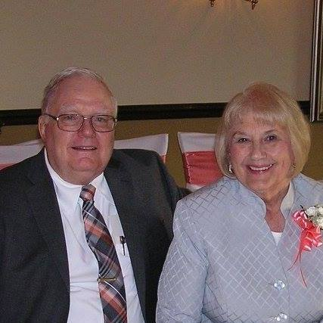
A Kentuckian by birth and in spirit, Dr. Jack Cottrell comes from the Minorsville Christian Church, near Stamping Ground, Kentucky. Dr. Cottrell has a BA in philosophy from the University of Cincinnati; an MDiv from Westminster Theological Seminary; and a PhD in theology from Princeton Theological Seminary. He was a Professor of Theology at Cincinnati Christian University from September 1967 to December 2015 — a total of forty-eight and a half years.

Barbara Cottrell has a B.A. in Sacred Literature from Cincinnati Bible Seminary and spent several years volunteering at Cincinnati Christian University one day a week as a receptionist in the Ministries Building. She is currently a member of the Mount Healthy Christian Village Auxiliary, and helps serve meals there once a month. As a member of First Church of Christ in Greendale, Indiana, she works in the nursery, teaches vacation Bible school, and helps with the youth program as needed.

