Introduction to the Book of Acts

The focus of this study will be to look at:  What were the key Scriptures and key issues affecting the early church and how did the church resolve these issues?  How did the early church view Jesus?  How did the Holy Spirit intervene in history to radically change Judaism forever?    We will also look at the social, political, religious and cultural events that affected and shaped the early church.

Book for the Class

[Acts of the Apostles, A Small Group Bible Study Guide](http://www.amazon.com/dp/0985010223/ref=rdr_ext_tmb) by [Ted LaFemina](http://www.amazon.com/s/ref=rdr_ext_aut?_encoding=UTF8&index=books&field-author=Ted%20LaFemina)

Timeline

1. D.

30 Pentecost

33 or 34 Conversion of Saul

42 or 43 Barnabas co-opts Saul in his labors in Antioch

44 (fixed) Herodian persecution and visit of Barnabas and Saul to

Jerusalem

45-47 Paul’s first missionary journey

47-48 Period in Antioch and visit to Jerusalem on

circumcision question (Chapter 15-14 years after Saul’s

conversion)

48-52 Paul’s second missionary Journey (end fixed by Gallio’s

proconsulship)

52-57 Paul’s third missionary journey

57 Paul arrested in Jerusalem

57-59 Paul a prisoner in Caesarea

60-62 Paul a prisoner in Rome

62 Probably freed

65 (?) Martyrdom in Rome

(From *The International Bible Commentary*, p. 1268)

(See also p. 45-46 in *Acts* book)

Chapter 1

V1-7 v3. Is52:13-Is53:12 Early on in the Christian movement the

church leaders were all Jewish. Consequently, the gospel

was presented from an all Jewish perspective.

Chapter 2

V1-21 Joel2:27-32 Scriptures used to prove Jesus to be the Christ.

V22-28 Ps16:8-11

V34-36 Ps110:1, Ps110:4

Chapter 3

V11-26 v18 🡪 Is59:1-12, Ps22:12-18 Suffering Messiah

V23 🡪 Dt18:15, 18, 19

V24 🡪 Gen22:18, 26:4

Chapter 4

V4-17 V4 What is the conflict going on here? Sadducees vs Pharisees

V11 🡪 Ps118:22

V18-31 v25-26 Ps2:1-2 This a Messianic prophecy that actually uses

the word messiah. Messiah = anointed, chosen

one, deliverer

Chapter 5

V17-19 What does this tell us about the Sadducees?

V29-39 Ps110:1 Right hand represents power and authority of God

(Heb 8:1) The right hand of God is not difficult to understand if it is taken in context. **The context shows that it is symbolic**. There are many problems that are created by trying to make the right hand of God literal. Mainly, if it is literal, Jesus is a separate being standing next to God, making Jesus either a separate God or not God at all. This teaching contradicts scripture.

The right hand of God is figurative. It is symbolic of God’s power and strength; His salvation, and majesty. It demonstrates God’s omnipotence. It shows the saving power of Jesus as God manifested in flesh. It demonstrates that Jesus, who had the saving power of God, has sat down from his saving work to reign as Almighty God.

Chapter 6

V1-7 What is the problem in the church?

-Communal living in church because large numbers had been

converted from out of town, remember day of Pentecost

-Short history of Diaspora and Greek speaking lingua franca

-Hebraic Jews and Grecian Jews (all Jews)

-Here we begin to see how the church dealt with practical

problems in a spiritual way

v8-15 Notice that Jews who were not believers in Jesus, began the

rumors that Jewish believers were already teaching to abandon

Moses and the Law. This was prior to any Gentiles being

converted.

Why was this such a powerful charge against the Christians?

Think about the Jewish tendency to leave the Law and worship

idols.

Chapter 7

V1-37 v37 Notice that Stephan mentions Dt18:15-20 v20 is key to the

Jews who did not believe that Jesus was the Messiah.

What Scriptures does Stephan cite in his monologue?

Gen12:1, Gen15:13-14, Gen29:31-35, Gen37:1-28, Gen41:41-47:12, Ex1:1-3, Ex32, Amos5:25-27, Josh3:14- 17, 2Sam7:8-16, 1King8:27, 2Chron2:6, Is66:1-2

What does the O.T. say to do with blasphemers?

**Lev24:14-16, Dt13:6-18**

It was risky business stoning somebody to death without Roman permission, but the crowd may have been so infuriated that they took the risk. Execution was only warranted if Roman authority agreed. Pilate obviously was not consulted.

It is not clear if Paul himself was a young but accepted member of the Sanhedrin.

Chapter 8

V27-37 Conversion of Ethiopian Eunuch 🡪 May have been a convert to

Judaism or maybe he was in process (Proselyte) or a God

Fearer. But a Eunuch could not be fully integrated into the Temple. Eunuchs were forbidden to enter the Temple. However, he could not have a full Jew because eunuchs were not allowed in the temple (Dt 23:1, Lev 22:25).

What type of Jew was this Eunuch? Not clear. He could have been a proselyte or an actual Jew of Jewish descent.

There are two kinds of proselytes in [Rabbinic Judaism](https://en.wikipedia.org/wiki/Rabbinic_Judaism); *ger tzedek* (righteous proselytes, proselytes of righteousness, religious proselyte, devout proselyte) and *ger toshav* (resident proselyte, proselytes of the gate, limited proselyte, half-proselyte)

A "righteous proselyte" is a [gentile](https://en.wikipedia.org/wiki/Gentile) who has converted to Judaism, is bound to all the doctrines and precepts of the Jewish religion, and is considered a full member of the Jewish people. The proselyte is circumcised as an adult (*[milah l'shem giur](https://en.wikipedia.org/wiki/Brit_milah" \l "Milah_l.27shem_giur" \o "Brit milah)*), if male, and immerses in a [*mikvah*](https://en.wikipedia.org/wiki/Mikvah) to formally effect the conversion.

A "gate proselyte"[[5]](https://en.wikipedia.org/wiki/Proselyte#cite_note-5) is a [resident alien](https://en.wikipedia.org/wiki/Resident_alien) who lives in the Land of Israel and follows some of the customs. They are not required to be circumcised nor to comply with the whole of the Torah. They are bound only to conform to the [Seven Laws of Noah](https://en.wikipedia.org/wiki/Seven_Laws_of_Noah) (do not worship idols, do not blaspheme God's name, do not murder, do not commit fornication (immoral sexual acts), do not steal, do not tear the limb from a living animal, and do not fail to establish rule of law) to be assured of a place in the [world to come](https://en.wikipedia.org/wiki/World_to_come).

We know that he was from Africa. Judaism was worldwide.

Judaism was not just in Jerusalem. The O.T. was already

becoming obsolete? Why?

Many of the O.T. Laws could not be put into practice because

Jews were not in Israel anymore. They were scattered all over

the known world. Leaders set up the synagogue system after

exile to Babylon. Synagogue history.

Chapter 9

V1-16 Are there any Scriptures that prophecy salvation for the gentiles?

* [Genesis 12:3](http://www.biblegateway.com/passage/?search=genesis%2012:3&version=NLT)
* [Psalm 22:27](http://www.biblegateway.com/passage/?search=psalm%2022:27&version=NLT)
* [Isaiah 42:4](http://www.biblegateway.com/passage/?search=isaiah%2042:4&version=NLT)
* [Isaiah 49:6](http://www.biblegateway.com/passage/?search=isaiah%2049:6&version=NLT)

[**Isaiah 49:6 (NLT)**](http://www.biblegateway.com/passage/?search=isaiah%2049:6&version=NLT)  
6      He says, “You will do more than restore the people of Israel to me.  
             I will make you a light to the Gentiles,  
             and you will bring my salvation to the ends of the earth.”

* [Isaiah 56:3-7](http://www.biblegateway.com/passage/?search=isaiah%2056:3-7&version=NLT)
* [Isaiah 60:1-3](http://www.biblegateway.com/passage/?search=isaiah%2060:1-3&version=NLT)
* [Jeremiah 16:19-21](http://www.biblegateway.com/passage/?search=jeremiah%2016:19-21&version=NLT)
* [Zechariah 2:11](http://www.biblegateway.com/passage/?search=Zechariah%202:11&version=NLT)

[**Zechariah 2:11 (NLT)**](http://www.biblegateway.com/passage/?search=Zechariah%202:11&version=NLT)

11Many nations will join themselves to the Lord on that day, and they, too, will be my people. I will live among you, and you will know that the Lord of Heaven’s Armies sent me to you.

* [Malachi 1:11](http://www.biblegateway.com/passage/?search=malachi%201:11&version=NLT)
* [Romans 15:9-12](http://www.biblegateway.com/passage/?search=romans%2015:9-12&version=NLT) (These are different wordings of Psalm 18:49, Deuteronomy 32:43, Psalm 117:1, and Isaiah 11:10.)

V19-22 Paul was busy proving that Jesus was the Christ.

Make up of Sanhedrin

**Ancient Jewish History:  
The Sanhedrin**

**by Shira Schoenberg**

**Ancient Jewish History:**[**Table of Contents**](https://www.jewishvirtuallibrary.org/jsource/Judaism/jewhist.html)**|**[**The Temples**](https://www.jewishvirtuallibrary.org/jsource/Judaism/templetoc.html)**|**[**Twelve Tribes**](https://www.jewishvirtuallibrary.org/jsource/Judaism/tribes.html)

|  |  |  |  |
| --- | --- | --- | --- |
| [Print Friendly and PDF](http://www.printfriendly.com/) |  |  |  |

The ancient Jewish court system was called the Sanhedrin. The Great Sanhedrin was the supreme religious body in the Land of Israel during the time of the [Holy Temple](https://www.jewishvirtuallibrary.org/jsource/Judaism/The_Temple.html). There were also smaller religious Sanhedrins in every town in the Land of Israel, as well as a civil political-democratic Sanhedrin. These Sanhedrins existed until the abolishment of the rabbinic patriarchate in about 425 C.E.

The earliest record of a Sanhedrin is by Josephus who wrote of a political Sanhedrin convened by the [Romans](https://www.jewishvirtuallibrary.org/jsource/History/Romans.html) in 57 B.C.E. Hellenistic sources generally depict the Sanhedrin as a political and judicial council headed by the country’s ruler.

Tannaitic sources describe the Great Sanhedrin as a religious assembly of 71 sages who met in the Chamber of Hewn Stones in the [Temple](https://www.jewishvirtuallibrary.org/jsource/Judaism/The_Temple.html) in [Jerusalem](https://www.jewishvirtuallibrary.org/jsource/Peace/jerutoc.html). The Great Sanhedrin met daily during the daytime, and did not meet on the [Sabbath](https://www.jewishvirtuallibrary.org/jsource/Judaism/Shabbattoc.html),[festivals](https://www.jewishvirtuallibrary.org/jsource/Judaism/holiday0.html) or festival eves. It was the final authority on Jewish law and any scholar who went against its decisions was put to death as a *zaken mamre* (rebellious elder). The Sanhedrin was led by a president called the *nasi* (lit. "prince") and a vice president called the *av bet din*(lit. "father of the court"). The other 69 sages sat in a semicircle facing the leaders. It is unclear whether the leaders included the high priest.

The Sanhedrin judged accused lawbreakers, but could not initiate arrests. It required a minimum of two witnesses to convict a suspect. There were no attorneys. Instead, the accusing witness stated the offense in the presence of the accused and the accused could call witnesses on his own behalf. The court questioned the accused, the accusers and the defense witnesses.

The Great Sanhedrin dealt with religious and ritualistic [Temple](https://www.jewishvirtuallibrary.org/jsource/Judaism/The_Temple.html) matters, criminal matters appertaining to the secular court, proceedings in connection with the discovery of a corpse, trials of adulterous wives, tithes, preparation of Torah Scrolls for the king and the Temple, drawing up the calendar and the solving of difficulties relating to ritual law.

In about 30 C.E., the Great Sanhedrin lost its authority to inflict capital punishment. After the Temple was destroyed, so was the Great Sanhedrin. A Sanhedrin in Yavneh took over many of its functions, under the authority of Rabban Gamliel. The rabbis in the Sanhedrin served as judges and attracted students who came to learn their oral traditions and scriptural interpretations. From Yavneh, the Sanhedrin moved to different cities in the Galilee, eventually ending up in [Tiberias](https://www.jewishvirtuallibrary.org/jsource/vie/Tiberias.html).

Local Sanhedrins consisted of different numbers of sages, depending on the nature of the offenses it dealt with. For example, only a Sanhedrin of 71 could judge a whole tribe, a false prophet or the high priest. There were Sanhedrins of 23 for capital cases and of three scholars to deal with civil or lesser criminal cases.

Chapter 10

V1-48 v1-2 What did it mean for Cornelius and his family to be devout

and God fearing?

**Theological significance of the God-fearers**

God-fearers (or 'Fearers of God') are consideredto be of significant importance to the popularity of the [Early Christian](https://en.wikipedia.org/wiki/Early_Christian) movement. They represented a group of gentiles who shared religious ideas with Jews, to one degree or another. However, they were not converts, but a separate gentile community, engaged in [Judaic religious ideas](https://en.wikipedia.org/wiki/Judeo-Christian#Ethical_value_system) and practices. Actual [conversion to Judaism](https://en.wikipedia.org/wiki/Conversion_to_Judaism) would require adherence to all of the [Laws of Moses](https://en.wikipedia.org/wiki/613_Mitzvot), which includes various prohibitions ([kashrut](https://en.wikipedia.org/wiki/Kashrut), [circumcision](https://en.wikipedia.org/wiki/Circumcision_in_the_Bible), [Sabbath](https://en.wikipedia.org/wiki/Biblical_Sabbath) observance etc.) which were generally unattractive to would-be gentile (largely Greek) converts. The rite of circumcision was especially unpopular in [Classical civilization](https://en.wikipedia.org/wiki/Classical_civilization) because it was the custom to spend an hour a day or so exercising in the [nude](https://en.wikipedia.org/wiki/Nude) in the [gymnasium](https://en.wikipedia.org/wiki/Gym) and males did not want to be seen in public deprived of their [foreskins](https://en.wikipedia.org/wiki/Foreskin).[[9]](https://en.wikipedia.org/wiki/God-fearer#cite_note-9)

The message of [St. Paul](https://en.wikipedia.org/wiki/St._Paul), (see [Paul of Tarsus and Judaism](https://en.wikipedia.org/wiki/Paul_of_Tarsus_and_Judaism)), stressed that [faith](https://en.wikipedia.org/wiki/Faith_in_Christianity) in Jesus constituted a [new covenant](https://en.wikipedia.org/wiki/New_covenant) with God, a [covenant](https://en.wikipedia.org/wiki/Covenant_(biblical)) which essentially provides a '[free gift](https://en.wikipedia.org/wiki/Free_gift)' of [salvation](https://en.wikipedia.org/wiki/Salvation) from the harsh edicts of the [Mosaic Law](https://en.wikipedia.org/wiki/Mosaic_Law) (see also [Christian liberty](https://en.wikipedia.org/wiki/Christian_liberty)). The Law of Moses was considered[[*by whom?*](https://en.wikipedia.org/wiki/Wikipedia:Manual_of_Style/Words_to_watch#Unsupported_attributions)] therefore to have little relevance to the [Pauline Christian](https://en.wikipedia.org/wiki/Pauline_Christian) community, (see [Pauline passages supporting antinomianism](https://en.wikipedia.org/wiki/Antinomianism#Pauline_passages_supporting_antinomianism)), as the [sacrifice of the Christ](https://en.wikipedia.org/wiki/Atonement_in_Christianity) was seen as a liberation from the demand that a person follow the Law without deviation, see also [Abrogation of Old Covenant laws](https://en.wikipedia.org/wiki/Abrogation_of_Old_Covenant_laws). This message was taken up by the God-fearers,[[*citation needed*](https://en.wikipedia.org/wiki/Wikipedia:Citation_needed)] who already represented a sizable group of people. In Paul's message of salvation through faith as opposed to works, the God-fearers found an essentially Jewish group to which they could belong without the necessity of their accepting Jewish Law. Aside from earning Paul's group a wide following, this view was generalized in the eventual conclusion that converts to Christianity need not first accept all Jewish Law, (see [Apostolic Decree](https://en.wikipedia.org/wiki/Apostolic_Decree)), a fact which was indispensable to the popularity of the early Christian movement and which would eventually lead to the [distinction between Judaism and Christianity as two separate religions](https://en.wikipedia.org/wiki/Split_of_early_Christianity_and_Judaism).

Why did God choose Cornelius?

-Roman centurion

-God fearer: attended synagogue and modified his life so as not to offend the Jews

-Gifts to the poor

-Influence

-All of family feared God

-His heart to share God with others

-location where he served

-What might be some other reasons?

Chapter 11

How did the church react to the Gentile conversions?

## The Reaction

The events at Caesarea had scarcely been concluded before the news of this Jewish-Gentile alliance had spread to Hebrew Christians in Jerusalem, some sixty-five miles to the southeast. Note carefully the following:

“And when Peter was come up to Jerusalem, they that were of the circumcision contended with him, saying, ‘You went in to men uncircumcised, and did eat with them’” (Acts 11:2-3).

The term “contended” is from the Greek diakrino, which here signifies “to take a firm position against,” and the imperfect tense form suggesting persistent opposition. It was a volatile situation; one that could have damaged the early church dramatically.

V1-18 7 maybe 10 years into beginning of church

V19-30 Book of Romans mentions this collection

V25-26 First called Christians by outsiders and enemies

Barnabus goes and gets Paul. This is first time we

see Paul stepping up to lead in the church.

Chapter 12

V1-17 Herod Agrippa I was totally loyal to Rome but understood the

importance of having favor with the local Jewish community.

Persecuting this Jewish sect that followed Jesus was an easy

target.

Why did God miraculously save Peter and not James?

V19b-23 God strikes down Herod.

Chapter 13

Let’s look at some of the O.T. Scriptures that Paul uses to preach to the Jews at this synagogue:

N.T.

V24 John’s Testimony Mt1:21; 3:11; Jhn1:27

V26 Pilate’s story Mt28:16; Lk24:48; Acts3:17

O.T.

V33 Psalms2:7

V34 Isaiah55:3

V35 Ps16:10

V41 Hab1:5

Paul had no doubt about his apostleship as apostle to the gentiles: He quotes Is49:6. He states very clearly that he (Paul) is this light to the Gentiles.

V1-9

Paul’s influence in spreading the gospel can hardly be overstated. From A.D. 45-57 (12 years) the gospel spread from Palestine to the Adriatic. Paul had probably been a disciple for about 12-14 years when Barnabas asked Paul to teach in Antioch (Acts11:25). Here is when Saul is first called Paul in the Bible (Saul in v1, 2, 7, 9 and Paul in verse 9). Why the change? Saul is Jewish name and Paul is Roman/Latin name.

Paul is trying to be all things to all men.

Notice the pattern: v5, 14, 42, 43, 44-46

Why did Paul and Barnabas go to the Jews first? Jews are the people of God through whom the messiah came. It was also a practical strategy. Paul knew there were people there ready to hear his message.

V7

Who was Sergius Paulus? A [boundary stone](https://en.wikipedia.org/wiki/Boundary_marker) of [Claudius](https://en.wikipedia.org/wiki/Claudius) mentioning Sergius was discovered at Rome in 1887[[1]](https://en.wikipedia.org/wiki/Sergius_Paulus#cite_note-1) by Sir William Ramsay. It records the appointment (AD 47) of the [Curators](https://en.wikipedia.org/wiki/Curator) of the banks and the channel of the river [Tiber](https://en.wikipedia.org/wiki/Tiber), one of whom was Sergius. Since Paul's journey to Cyprus is usually dated to the first half of the 40s (and some scholars date his visit even earlier), it is thought Sergius may have first served three years as Proconsul at Cyprus, then returned to [Rome](https://en.wikipedia.org/wiki/Rome), where he was appointed curator.

[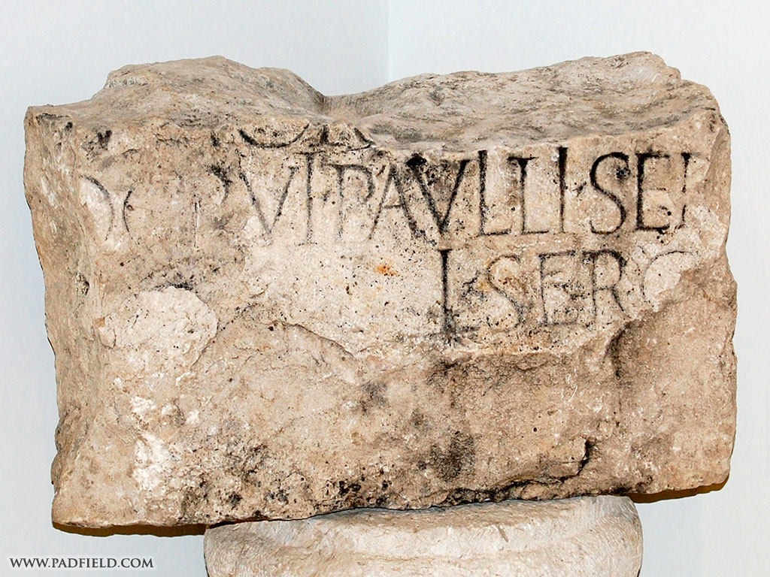](http://www.google.com/url?sa=i&source=imgres&cd=&cad=rja&uact=8&ved=0CAkQjRwwAGoVChMIjp76q5H6xgIVxDKICh1Irwxp&url=http://padfield.com/turkey/yalvac/index.html&ei=Goa1VY6pEcTloATI3rLIBg&psig=AFQjCNHzoY9ZTuGV9JGc-4RsaIbJ5NTU4A&ust=1438046106403644)

William Ramsay was known for his careful attention to New Testament events, particularly the [Book of Acts](https://en.wikipedia.org/wiki/Book_of_Acts) and [Pauline Epistles](https://en.wikipedia.org/wiki/Pauline_Epistles). When he first went to Asia Minor, many of the cities mentioned in Acts had no known location and almost nothing was known of their detailed history or politics. The Acts of the Apostles was the only record and Ramsay, skeptical, fully expected his own research to prove the author of Acts hopelessly inaccurate since no man could possibly know the details of Asia Minor more than a hundred years after the event—this is, when Acts was then supposed to have been written. He therefore set out to put the writer of Acts on trial. He devoted his life to unearthing the ancient cities and documents of Asia Minor. After a lifetime of study, however, he concluded: 'Further study . . . showed that the book could bear the most minute scrutiny as an authority for the facts of the Aegean world, and that it was written with such judgment, skill, art and perception of truth as to be a model of historical statement' (*The Bearing of Recent Discovery*, p. 85). On page 89 of the same book, Ramsay accounted, 'I set out to look for truth on the borderland where Greece and Asia meet, and found it there [in Acts]. You may press the words of Luke in a degree beyond any other historian's and they stand the keenest scrutiny and the hardest treatment...'

When Ramsay turned his attention to Paul's letters, most of which the critics dismissed as forgeries, he concluded that all thirteen New Testament letters that claimed to have been written by Paul [were authentic](https://en.wikipedia.org/wiki/Authorship_of_the_Pauline_epistles).

Paul’s First Missionary Journey

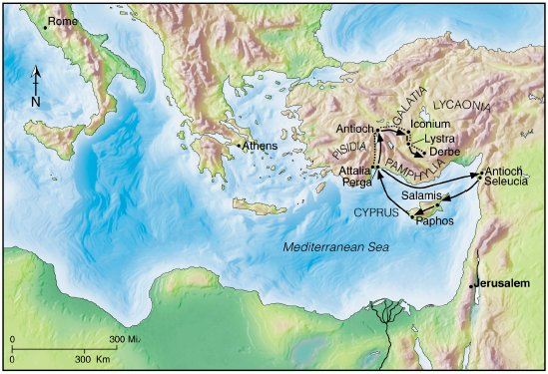

Chapter 14

V1 Paul and Barnabas continue custom of going to preach at the synagogues.

V22 Early Christians knew that hardship was part of being in the Kingdom of God.

V23 Putting trust in the Lord means trusting in the face of hardships.

Chapter 15

V1-12 Why did this issue come up?

Some Possible Reasons

● More and more Gentiles were being converted.

v5 ● More and more Pharisees were being converted (were

politics entering the church?). Recall that the Pharisees

were a great political force.

● More and more persecution was coming upon the church and

perhaps some wanted to avoid it.

v3 As a whole, the Church was happy that the Gentiles converted.

V13-21 v15 Notice how James goes back to O.T. prophets. Here James

quotes Am9:11-12.

James, the brother of Jesus, was very influential in the

church. What was his wise counsel? Why was it wise?

V22-35 Early on, the apostles understood the importance of unity and

encouragement.

What implications does that hold for us today?

V36-41

Paul and Barnabas had a sharp disagreement. What did they decide to do? Continue the work in the way that they felt God was calling them to do it. They split it up. Paul went east to Syria and Cilicia and Barnabas went west to Cyprus. They taught and strengthened the churches and served God and kept their friendship.

Why did they see things differently even though they were both great men of God?

What implications does this have for us today?

Barnabas was related to John mark.

Barnabas was a shepherd at heart.

Paul was about the work and fighting through challenges.

Paul needed reliable people to go on such dangerous missions.

Paul saw John Mark’s failings (Acts13:13). Both were right.

John Mark made good with Paul later: Col4:10, Philemon 23, 2 Tim4:11

Chapter 16

V3 Why did Paul circumcise Timothy? Timothy was half Jewish. It

would help with his outreach to the Jews.

Galatia 🡪 Celts: they migrated from Turkey to Ireland

V11-16 Phillipi was a Roman colony started in 42 B.C. It probably did

not have a Jewish Synagogue. May be first place of missionary

work in European continent.

V19-24 Recall that Phillipi was a Roman colony. But the disciples were

Jewish leaders of a new religion. The accusations against the

disciples may have been based in the fact that Rome had

legitimate religions and illegitimate religions. There was actually

a group called the concilia that helped decide what religions

were considered legal to teach and practice. The legal religions

were called “religio licita.” They were authorized by imperial

law.

Why did Paul bring up his Roman citizenship after the fact of the beating and jailing? Maybe it would help protect the fledging church that he would have to leave behind. There is no doubt that this church survived and prospered. Paul writes to them later in Phillipians and says that they were close to his heart (Phil1:3-7).

The rights of Roman citizens were laid down in a long succesion of laws (most recently the *lex Julia de vi publica*), going back traditionally to the *lex Valeria* of 509 B.C. They included exemption from certain ignominious forms of punishment, protection against summary execution, and the right of appeal to the sovereign authority.

When a man claimed his citizen rights — when he said *civis Romanus sum* (“I am a Roman citizen”) or its equivalent in Greek — how did he prove his claim? Certainly it was a capital offense to claim falsely to be a Roman citizen, but how did an official know whether the claim was true? A new citizen might have a duly witnessed copy of his certificate of citizenship; auxiliary soldiers received such a document when they were enfranchised, and civilians may have been given something similar. But Paul was not a new citizen. He might, however, have produced a diptych containing a certified copy of his birth registration. Each legitimate child of a Roman citizen had to be registered within (it appears) thirty days of birth

 (cf. F. Schulz, *Journal of Roman Studies*, 32 [1942], 78ff; 33 [1943], 55ff).

If he lived in the provinces, his father or some duly appointed agent made a declaration in the appropriate record office that the child was a Roman citizen (civem Romanum esse professus est); the declaration was recorded in the official register, and the father or agent received a copy in diptych form, properly certified by witnesses.

It is doubtful that an itinerant Roman citizen customarily carried this diptych around with him. F. Schulz was sure that Paul did so and produced it for corroboration when he claimed civic privileges (*Journal of Roman Studies*, 33 [1943], 63f). A. N. Sherwin-White, however, thought it more likely that such certificates were normally kept in the family archives (Roman Society and Roman Law in the NT [1963], p. 149; cf. Roman Citizenship [1939]).

A further point to consider is that registration of Roman citizens at birth was apparently enacted by the lex Aelia Sentia of A.D. 4 and the lex Papia Poppaea of 9; if Paul was born even a year or two before the earlier enactment, he might not have been registered in this way. (F.F. Bruce, "Paul the Apostle", in The International Standard Bible Encyclopedia. Vol. 3: K-P, ed. by. G. Bromiley (Eerdmans, 1995), pages 709-710.}

Chapter 17

V6 Luke rightly calls the civic authorities πολιτάρχας ‘politarchs,’

a designation found on inscriptions for the chief magistrates of

several Macedonian cities.

|  |  |  |  |  |  |
| --- | --- | --- | --- | --- | --- |
| This part of a Roman gateway | |  | | --- | |  | |  | | |  | | --- | | The picture below shows a Greek inscription discovered in 1835 on an arch in  Thessalonika which lists the officials in the town in the second century AD. It  begins by listing six “politarchs.” Since then the same term has been found on  other inscriptions in Thessalonika. | | |
|  |

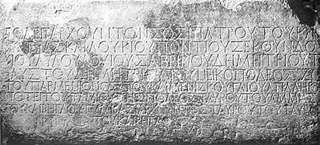

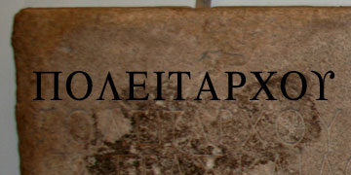

Above there were stone inscriptions found in Thessalonica after the gateway was demolished in 1876. The inscription mentions the “city rulers” of Thessalonica, using a term that was used in Macedonia, politarche in Greek. The boldface letters were placed to give relief to the actual inscription.

V4 Interesting how often the Bible mentions that prominent

women were instrumental in the early church.

V16-22

Stoics taught that destructive emotions resulted from errors in judgment, and that a [sage](http://en.wikipedia.org/wiki/Sage_%28Sophos%29), or persons of "moral and intellectual perfection," would not suffer such emotions. Stoics were concerned with the active relationship between cosmic [determinism](http://en.wikipedia.org/wiki/Determinism) and human [freedom](http://en.wikipedia.org/wiki/Freedom_of_will), and the belief that it is [virtuous](http://en.wikipedia.org/wiki/Virtue) to maintain a [will](http://en.wikipedia.org/wiki/Prohairesis) (called [*prohairesis*](http://en.wikipedia.org/wiki/Prohairesis)) that is in accord with nature. Because of this, the Stoics presented their philosophy as a way of life, and they thought that the best indication of an individual's philosophy was not what a person said but how that person behaved.

Epicureanism is a form of [hedonism](http://en.wikipedia.org/wiki/Hedonism), insofar as it declares pleasure to be the sole intrinsic good, its conception of absence of pain as the greatest pleasure and its advocacy of a simple life make it different from "hedonism" as it is commonly understood.

Areopagus

The hill of Mars, the seat of the ancient and venerable supreme court of Athens, called the Areopagites, [Acts 17:19-34](http://biblehub.com/context/acts/17-19.htm). It was composed entirely of ex-archons, of grave and blameless character, and their wise and just decisions made it famous far beyond the bounds of Greece. Their numbers and authority varied greatly from age to age. They held their sessions by night. They took cognizance of murders, impieties, and immoralities; punished vices of all kinds, idleness included; rewarded or assisted the virtuous; and were peculiarly attentive to blasphemies against the gods, and to the performance of the sacred mysteries. The case of Paul, therefore, would naturally come before them, for he sought to subvert their whole system of idolatry, and establish Christianity in its place. The Bible narrative, however, rather describes an informal popular movement. Having heard Paul discoursing from day to day in the market place, the philosophic and inquisitive Athenians took him one day up into the adjacent hill, for a fuller and quiet exposition of his doctrine. The stone seats of the Areopagus lay open to the sky; in the court stood Epicureans, Stoics, etc.; around them spread the city, full of idolaters and their temples; and little south-east rose the steep height of the Acropolis, on whose level summit were crowded more and richer idolatrous structures than on any other equal space in the world. Amid this scene, Paul exhibited the sin and folly of idol-worship with such boldness and power, that none could refute him, and some were converted.

The Areopagus, like most city-state institutions, continued to function in Roman times, and it was then that the **Apostle Paul** delivered his famous speech about the identity of "the Unknown God." According to the biblical account (Acts 17):

## History of Areopagus (Mars Hill)

In pre-classical times (before the 5th century BC), the Areopagus was the **council of elders** of the city, like the Roman Senate. Like the Senate, its membership derived from those who had held high public office, in this case that of Archon. In 462 BC, Ephialtes put through reforms which deprived the Areopagus of almost all its functions except that of a murder tribunal.

In classical times, the Areopagus functioned as the chief **homicide court** of Athens. At the foot of the Areopagus was a **temple** dedicated to the Erinyes, where murderers could find sanctuary.

## Myth and Mystery

According to Greek mythology, Ares (the god of war, known to the Romans as Mars) was tried here by the gods for the murder of Poseidon's son Alirrothios. It is this legend that gives the hill its various names. Another legend says that the hill was the site of the trial of Orestes for killing his stepmother and her lover, Clytemnestra and Aegisthus.

## What to See at Areopagus (Mars Hill)

The Areopagus is a bare marble hill across from the entrance to the Acropolis.

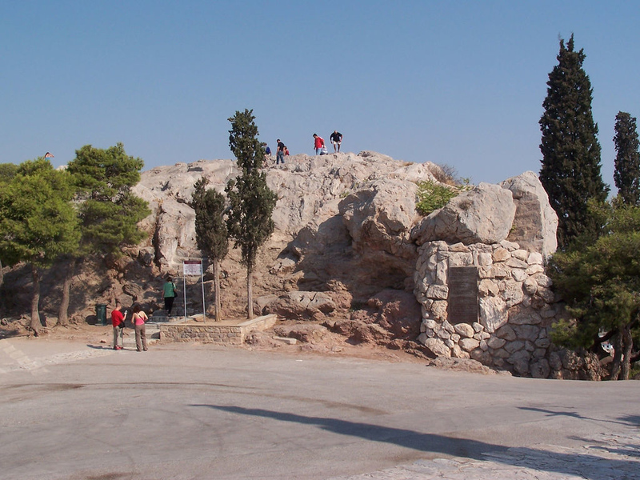

[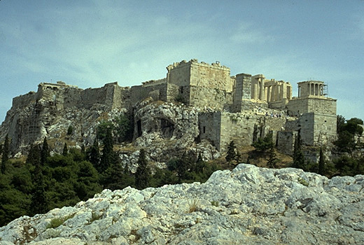](http://www.google.com/url?sa=i&rct=j&q=&esrc=s&frm=1&source=images&cd=&cad=rja&uact=8&ved=0CAcQjRxqFQoTCIbaza7LgccCFZCjiAodkksGZw&url=http://www.greece-athens.com/photo.php?photo_id%3D91&ei=d265VcbCEJDHogSSl5m4Bg&bvm=bv.99028883,d.cGU&psig=AFQjCNGVtw1f6sQ-1L7k_0KDnRHaQjXgCg&ust=1438302197928454)

**Above, the Acropolis as seen from the Areopagus.**

The Acropolis of Athens is an ancient citadel located on a high rocky outcrop above the city of Athens and contains the remains of several ancient buildings of great architectural and historic significance, the most famous being the Parthenon.

The Parthenon is a former temple on the Athenian Acropolis, Greece, dedicated to the goddess Athena, whom the people of Athens considered their patron. Construction began in 447 BC when the Athenian Empire was at the height of its power.

[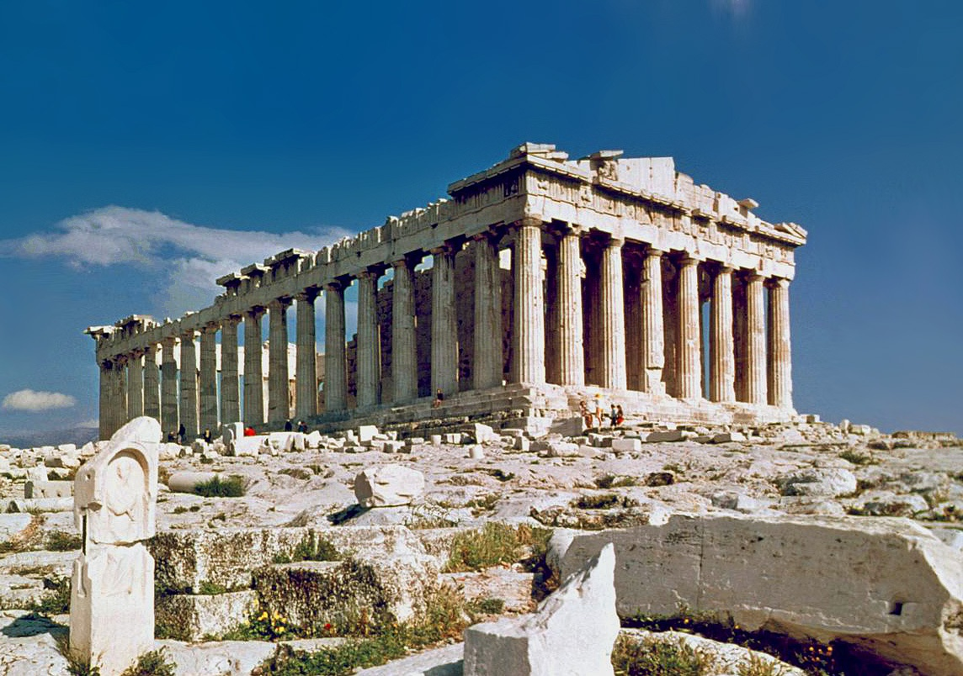](http://www.google.com/url?sa=i&source=imgres&cd=&cad=rja&uact=8&ved=0CAkQjRwwAGoVChMIgJC7ucyBxwIVxlyICh2e5wPR&url=https://en.wikipedia.org/wiki/Parthenon&ei=mm-5VYDbHMa5oQSez4-IDQ&psig=AFQjCNEA6E5wodY73tFgpW9XnWx56Eaatg&ust=1438302490612518)

V22-34

Paul quotes the writers Epimenides and Aratus, where Zeus is considered the source of all life.

**Epimenides** of [Knossos](https://en.wikipedia.org/wiki/Knossos) ([Crete](https://en.wikipedia.org/wiki/Crete)) ([/ɛpɨˈmɛnɨdiːz/](https://en.wikipedia.org/wiki/Help:IPA_for_English); [Greek](https://en.wikipedia.org/wiki/Greek_language): Ἐπιμενίδης) was a semi-[mythical](https://en.wikipedia.org/wiki/Greek_mythology) 7th or 6th century BC [Greek](https://en.wikipedia.org/wiki/Greeks) [seer](https://en.wikipedia.org/wiki/Prophet) and [philosopher](https://en.wikipedia.org/wiki/Philosopher)-[poet](https://en.wikipedia.org/wiki/Poetry). While tending his father's sheep, he is said to have fallen asleep for fifty-seven years in a Cretan cave sacred to [Zeus](https://en.wikipedia.org/wiki/Zeus), after which he reportedly awoke with the gift of prophecy ([Diogenes Laërtius](https://en.wikipedia.org/wiki/Diogenes_La%C3%ABrtius) i. 109–115). [Plutarch](https://en.wikipedia.org/wiki/Plutarch) writes that Epimenides purified [Athens](https://en.wikipedia.org/wiki/Athens) after the pollution brought by the [Alcmeonidae](https://en.wikipedia.org/wiki/Alcmeonidae), and that the seer's expertise in [sacrifices](https://en.wikipedia.org/wiki/Sacrifice) and reform of funeral practices were of great help to [Solon](https://en.wikipedia.org/wiki/Solon) in his reform of the Athenian state. The only reward he would accept was a branch of the sacred olive, and a promise of perpetual friendship between Athens and [Cnossus](https://en.wikipedia.org/wiki/Cnossus) (Plutarch, *Life of Solon*, 12; [Aristotle](https://en.wikipedia.org/wiki/Aristotle), [*Ath. Pol*](https://en.wikipedia.org/wiki/Constitution_of_the_Athenians#Aristotle). 1).

Luke shows that the Athenians were not likely to receive the gospel with wide open arms but a few believed, among them Dionysius and Damaris. The church was founded and the only true temple to the only true God was established amid the many shrines and temples of Athens.

According to [Dionysius of Corinth](https://en.wikipedia.org/wiki/Dionysius_of_Corinth), quoted by [Eusebius](https://en.wikipedia.org/wiki/Eusebius_of_Caesarea), this Dionysius then became the first [Bishop of Athens](https://en.wikipedia.org/wiki/List_of_Archbishops_of_Athens). Many Christian writings have been ascribed to Dionysius.

Chapter 18

Read v1-10

V1

While Athens was the cultural capital of Greece and therefore the whole of Hellenistic civilization, Corinth was the commercial capital of Greece (think LA cultural and NY financial). Politically, Corinth was the capital of the Roman province of Achaia (think Sacramento). The great temple of Aphrodite made Corinth a center for idolatrous worship on the lowest possible moral level. The temple had female priestesses whose role was to prostitute themselves inside the temple as standard practice for worship.

Destroyed in Rome’s wars of conquest, Corinth was rebuilt in 46B.C. by Julius Caesar. It was rebuilt as a Roman colony.

V2-3 Paul meets Priscilla and Aquila who were expelled from Rome by

Claudius.

In support of the dates accepted by the majority of scholars for the Claudius expulsion of Jews from Rome, Ralph Novak states that the Delphi inscription clearly indicates that Gallio did not assume office any earlier than the spring of 50, adds that he may have served one or two years, and uses that to show how the date ranges are computed.

V11-18

### Dating Acts by reference to Gallio or to Orosius

[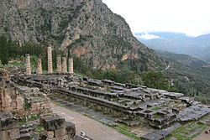](https://en.wikipedia.org/wiki/File:The_Temple_of_Apollo_at_Delphi.jpg)

The [Temple of Apollo](https://en.wikipedia.org/wiki/Temple_of_Apollo_(Delphi)), where the [Delphi Inscription](https://en.wikipedia.org/wiki/Delphi_Inscription) was discovered in the 20th century, used to date the proconsulship of Gallio which provides a peg for the chronology of Paul.[[4]](https://en.wikipedia.org/wiki/Claudius%27_expulsion_of_Jews_from_Rome#cite_note-4)

A fairly precise date for Acts 18:1-18 is derived from the mention of the [proconsul](https://en.wikipedia.org/wiki/Proconsul) [Gallio](https://en.wikipedia.org/wiki/Lucius_Junius_Gallio_Annaeanus) in 18:12 and the existence of an [inscription](https://en.wikipedia.org/wiki/Delphi_Inscription) found at [Delphi](https://en.wikipedia.org/wiki/Delphi) and published in 1905,[[5]](https://en.wikipedia.org/wiki/Claudius%27_expulsion_of_Jews_from_Rome#cite_note-5) preserving a letter from Claudius concerning Gallio dated during the 26th acclamation of Claudius, sometime between January 51 and August 52.[[6]](https://en.wikipedia.org/wiki/Claudius%27_expulsion_of_Jews_from_Rome#cite_note-6)

[Craig S. Keener](https://en.wikipedia.org/wiki/Craig_S._Keener) states that most scholars believe that the Delphi inscription "pinpoints" Gallio's term in Corinth to within a year or two and that his term started in July 51, although some scholars prefer 52.[[7]](https://en.wikipedia.org/wiki/Claudius%27_expulsion_of_Jews_from_Rome#cite_note-Keener51-7) [Udo Schnelle](https://en.wikipedia.org/wiki/Udo_Schnelle) states that dates for the reign of Gallio can be determined with a "fair degree of accuracy" given the Delphi inscription and his term started in the summer of 51.[[8]](https://en.wikipedia.org/wiki/Claudius%27_expulsion_of_Jews_from_Rome#cite_note-Udo49-8) An independent dating of Acts is sometimes based on a controversial AD 49 date for Claudius's edict, reported by [Orosius](https://en.wikipedia.org/wiki/Orosius): If Claudius's edict were issued in January of 49 and Paul came to Corinth and met Aquila and Priscilla, within six or so months of the edict, then an eighteen-month stay in Corinth would indicate a date after late spring of 50 and many days before January of 51 for Paul's trial.[[9]](https://en.wikipedia.org/wiki/Claudius%27_expulsion_of_Jews_from_Rome#cite_note-Novak18-9) At the other extreme, if Claudius's edict were issued in December of 49, using the same reasoning, the date of Paul's trial would be many days before the January of 52.[[9]](https://en.wikipedia.org/wiki/Claudius%27_expulsion_of_Jews_from_Rome#cite_note-Novak18-9) Michael R. Cosby states that the dates 49-50 for the expulsion of Jews from Rome support the date from the trial of Paul in Corinth, and are consistent with the account of the activities of Priscilla and Aquila given in Acts 18:24-26.[[10]](https://en.wikipedia.org/wiki/Claudius%27_expulsion_of_Jews_from_Rome#cite_note-Cosby142-10)

In summary, the two dating approaches provide a time window of maximally AD 49 to AD 53 for the events in Acts, with January 49 being the earliest possible date for Claudius's expulsions of Jews from Rome, and AD 53 being the latest possible date for the trial of Paul during Gallio's term of office.

### The health of Gallio[[edit](https://en.wikipedia.org/w/index.php?title=Claudius%27_expulsion_of_Jews_from_Rome&action=edit&section=3)]

Gallio's brother Seneca reports in [*Moral Epistles* 104.1](https://en.wikisource.org/wiki/Moral_letters_to_Lucilius/Letter_104) that Gallio *began to develop a fever in Achaia and took ship at once, insisting that the disease was not of the body but of the place*. Furthermore, [Pliny the Elder](https://en.wikipedia.org/wiki/Pliny_the_Elder) states in his [*Natural History*](https://en.wikipedia.org/wiki/Natural_History_(Pliny)) 31.33 that *There are numerous other medicinal resources derived from the sea; the benefit of a sea-voyage, more particularly, in cases of phthisis, as already mentioned, and where patients are suffering from hæmoptosis, as lately experienced, in our own memory, by Annæus Gallio, at the close of his consulship*.

Based on these references, [Jerome Murphy-O'Connor](https://en.wikipedia.org/wiki/Jerome_Murphy-O%27Connor) and a number of other scholars conclude that it is likely that the tenure of Gallio in Corinth lasted less than a full year. Gallio was the brother of Seneca, Nero’s tutor.

V10

Why did the Jews claim that Paul was teaching against Jewish Law. Recall, Judaism was a *religio licita* but this new teaching was not. They were trying to show that the teachings about Jesus was a *religio ilicita.*

Gallio was a major figure, being proconsul of Achaia, (think governor of a state). The lesser leaders in the province would have respected Gallio’s ruling/decision and thus would have allowed Paul and other disciples to teach. This tolerance of the disciples fulfilled God’s promise that no one would attack Paul in Corinth.

V24-27 Apollo comes on the scene. What do we know about him?

Jew, Egyptian (Alexandria), spoke Greek, new OT well, knew

prophecies about Jesus, only knew John’s baptism.

Acts 19

V1-9 Paul goes back to Ephesus as promised in Acts18:21

One of the most interesting passages in the Bible. Who were these

“disciples” who did not know about receiving the Holy Spirit?

Remember how little time Paul spent in Ephesus the first time he

went there. Was it lack of teaching, people from other places, etc?

What other reasons might these disciples not know about the Holy

Spirit?

V8. The strong opposition and public maligning of “the way” was why

Christians had to eventually break off from Judaism.

V18-29 Christianity spreading to the point where it is affecting the trade

in idols.

V29 Theatre at Ephesus: Held 25,000 spectators

[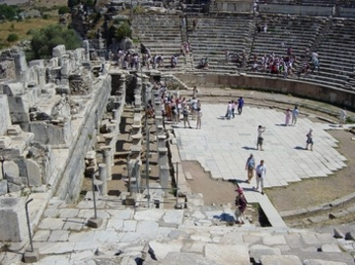](http://www.sacred-destinations.com/turkey/ephesus-theater/photos/theater-side-cc-griffhome)

[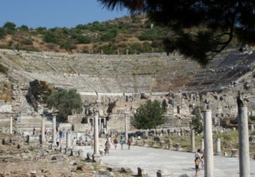](http://www.sacred-destinations.com/turkey/ephesus-theater/photos/theater-cc-malkav)

Chapter 20

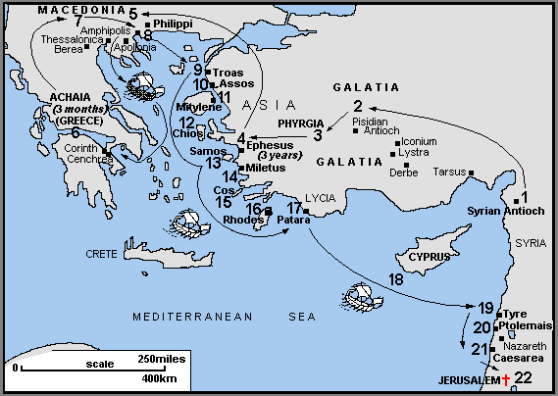

Map - Paul’s Third Missionary Journey, concluded c AD53-58

V17-38 Paul’s address to the elders of Ephesus

V28-30 Paul says in v30 that even men from among the

membership will speak perverse things to draw disciples

away.

What does this mean? What implications does this

have for the fellowship?

Chapter 21

V7-14 Why would Paul press on to Jerusalem despite the

warnings of danger from the Holy Spirit?

V18-25

The discussion has shifted from Gentiles needing to follow the law (Acts 15) to Jews who were converts following the Law.

Why was this still an issue in the church?

James wanted Paul to refute the claims that Paul was teaching rejection of the law to Jews. This would probably have been a barrier to the continued evangelization of Jews who had not accepted Jesus as the messiah yet and also a stumbling block for some Jewish brethren.

V29-32

They had seen Paul with Trophimus the Ephesian. Were they following Paul around spying on him? Maybe

How many Roman soldiers were present to save Paul? The text says centurions. Were there 200 soldiers or more?

V33-40

In the end it was not the Jerusalem Jews who started the uproar. As the week for the purification was coming to an end, some Jews from the Dispersion from Asia saw him in the temple. They accused him of teaching against the law and bringing a Gentile into the temple. There was a barrier separating the Court of the Gentiles from the inner parts of the Temple with warning notices on it threatening death to Gentiles who passed it. One such inscription was discovered in 1871 in a cemetery, and a portion of another in 1935 near St. Stephen’s Gate, in Jerusalem. The turmoil came about on the assumption that Paul had brought Trophimus into the Temple. Paul was dragged from the Temple itself into the Court of the Gentiles, which was overlooked by the garrison in the fortress of Antonia, to the northwest of the temple area.

V31

The officer commanding the cohort (a chiliarch or military tribune) was in charge of the Jerusalem garrison. A cohort consisted of six centuries, to which some cavalry was attached. They carried Paul from the Court of the Gentiles into the barracks.

The reference here to Paul being an Egyptian terrorist may be related to a false prophet that the Jewish historian Josephus mentions in his writings (Antiquities XX.8.6). This Egyptian false prophet led an attack on the city of Jerusalem but it was put down by Felix. The word terrorist is the Greek word:

[sikariōn](http://biblehub.com/greek/sikario_n_4607.htm)  
σικαρίων  ?  
assassins

**Sicarii** (Latin plural of **Sicarius** "dagger-men", in Modern Hebrew rendered *siqariqim* סיקריקים) is a term applied, in the decades immediately preceding the [destruction of Jerusalem in 70 CE](https://en.wikipedia.org/wiki/Siege_of_Jerusalem_(70)), to an extremist splinter group[[1]](https://en.wikipedia.org/wiki/Sicarii#cite_note-1) of the [Jewish](https://en.wikipedia.org/wiki/Jew) [Zealots](https://en.wikipedia.org/wiki/Zealotry), who attempted to expel the [Romans](https://en.wikipedia.org/wiki/Roman_Empire) and their partisans from the [Roman province](https://en.wikipedia.org/wiki/Roman_province) of [Judea](https://en.wikipedia.org/wiki/Judea_(Roman_province)).[[2]](https://en.wikipedia.org/wiki/Sicarii#cite_note-2) The Sicarii carried *sicae*, or small daggers, concealed in their cloaks, hence their name.[[3]](https://en.wikipedia.org/wiki/Sicarii#cite_note-3) At public gatherings, they pulled out these daggers to attack Romans or Roman sympathizers, blending into the crowd after the deed to escape detection. They were one of the earliest forms of an organized [assassination](https://en.wikipedia.org/wiki/Assassination) society or [cloak and daggers](https://en.wikipedia.org/wiki/Cloak_and_dagger), predating the Middle Eastern [assassins](https://en.wikipedia.org/wiki/Assassins) and Japanese [ninjas](https://en.wikipedia.org/wiki/Ninja) by centuries

V40

Paul spoke to them in the Jewish language which was Jewish

Aramaic



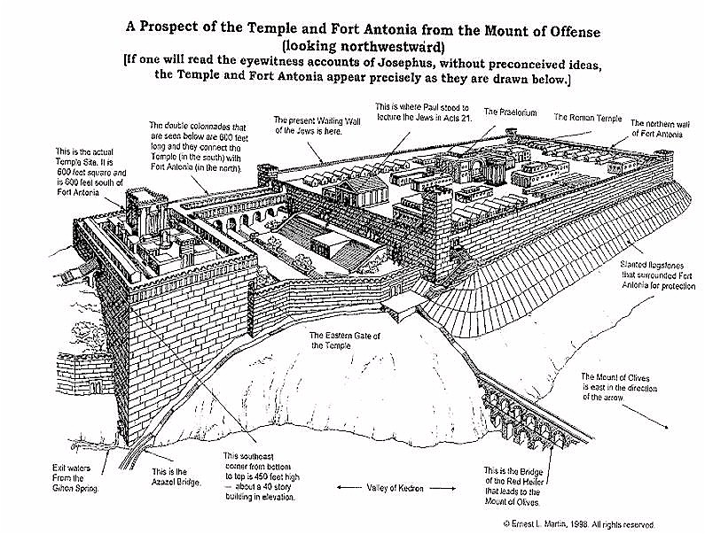

Acts 22

V1-29

V25

The Lex Porcia and Lex Julia made it against Roman law to flog a Roman citizen.

Chapter 23

V1-11

V1 It was against the Law for judges to punish people on trial before they were considered guilty. (Dt 25:1-2, Jn 7:51) Ananias went beyond the Law. Remember that Paul was also a Roman citizen and it was also against Roman law to beat a Roman citizen without cause. At this point Paul is still considered innocent. This is the reason that Paul tells Ananias that he is going against the Law (not only Jewish but Roman as well). Barnes tell us that “To punish unjustly a Roman citizen was deemed an offence to the majesty of the Roman people and was severely punished by the law. Dionysius Hali. (Ant, Rom. ii.) says that ‘The punishment appointed for those who abrogated or transgressed the Valerian law was death, and the confiscation of his property.’ The Emperor Claudius deprived the inhabitants of Rhodes of freedom for having crucified some Roman citizens.”[[1]](#footnote-1)

Ananias was the Jewish high priest from AD 47 to 58. – slap him: He apparently assumed that Paul was lying and tried to intimidate him.

One must remember that Paul was probably no stranger to the Sanhedrin. Though historical records do not show this, many in the Sanhedrin probably knew Paul personally. Recall that it was the Sanhedrin that gave Paul permission to go to Damascus to jail and kill the Christians following the way. (Acts 22:5) Is there a contradiction here? Paul said that he did not know that Ananias was High Priest and yet he asked the people to investigate these things with the High Priest and the Council (Sanhedrin). There are various theories as to why Paul said that he did not know that Ananias was High Priest.

Some believe Paul was being sarcastic as Ananias was known to be very corrupt. Some believe it could be that Paul had been traveling much and did not know the state of religious/political affairs in Jerusalem. Some state that maybe Paul was not facing Ananias and did not know who had ordered the striking on his mouth. It is not all together clear.

[**v3**](http://www.esvstudybible.org/search?q=Acts+23%3A3)

Paul, like Jesus, used the metaphor of whitewash for hypocrisy (see [Matt. 23:27](http://www.esvstudybible.org/search?q=Matt+23%3A27)). Tombs were whitewashed to prevent the defilement that would follow if anyone should touch them because they did not see them. Ananias was a particularly bad high priest. For the illegality of Ananias’s action, see [Lev. 19:15](http://www.esvstudybible.org/search?q=Lev+19%3A15).

**Ananias the son of Nedebaeus reigned as high priest from A.D. 48 to 58 or 59 and was known for his avarice and liberal use of violence. He was nominated High Priest in A.D. 48 by Herod Agrippa II and deposed about 10 years later. Josephus says he confiscated for himself the tithes given the ordinary priests and gave lavish bribes to Romans and also Jews (cf. Antiq. XX, 205-7 [ix.2], 213 [ix.4]). He was a brutal and scheming man, hated by Jewish nationalists for his pro-Roman policies. When the war with Rome began in A.D. 66, the nationalists burned his house (cf. Jos. War II, 426 [xvii.6]) and he was forced to flee to the palace of Herod the Great in the northern part of Jerusalem (ibid., 429 [xvii.6]). Ananias was finally trapped while hiding in an aqueduct on the palace grounds and was killed along with his brother Hezekiah (ibid., 441-42 [xvii.9]). Ananias’ servants were known to steal money offered in tithes for the common priests.**

The background information helps us understand why Ananias is quickly violent toward Paul and why Paul calls him a “white-washed wall.” Ananias was evil in the core, while pretending to be the holy high priest of the Jews.

Quadratus, governor of [Syria](https://en.wikipedia.org/wiki/Syria_(Roman_province)), accused him of being responsible for acts of violence. He was sent to [Rome](https://en.wikipedia.org/wiki/Rome) for trial (AD 52), but was acquitted by the emperor [Claudius](https://en.wikipedia.org/wiki/Claudius). Being a friend of the Romans, he was murdered by the people at the beginning of the [First Jewish-Roman War](https://en.wikipedia.org/wiki/First_Jewish-Roman_War).[[3]](https://en.wikipedia.org/wiki/Ananias_son_of_Nedebeus#cite_note-EB1911-3)

His son [Eliezar ben Hanania](https://en.wikipedia.org/wiki/Eliezar_ben_Hanania" \o "Eliezar ben Hanania) was one of the leaders of the [Great Revolt of Judea](https://en.wikipedia.org/wiki/Great_Revolt_of_Judea).

Paul must have known that Ananias was High Priest. Many scholars believe that Paul’s reply must have been sarcastic to infer that Ananias could never be a true High Priest because of his hypocrisy.

Paul quotes Ex22:28 to prove that he would never insult a true ruler of the people. For the sake of tranquility, the Roman authorities would still allow the High Priest to be called ruler.

V6

The Sadducees denied many aspects of the spiritual world.

The Pharisees and Sadducees were influential Jewish sects with conflicting philosophies in regards to the implementation of the Torah. Pharisees and Sadducees also had conflicting views about the role of government in the lives of Jewish citizens. The Pharisees believed that God had punished the Jews by allowing oppressive Pagans like the Romans to rule over them because the Jews refused to uphold the statutes of the Torah (Abels, 2005). This is [why](http://www.differencebetween.net/language/words-language/difference-between-how-come-and-why/) they supported the creation of distinctive laws which would keep the Jews from further offending God by adopting the lifestyles of non-Jews. While the Sadducees believed in the authority of the Torah, they were also more supportive of prevailing rulers (Abels, 2005). This is because they understood that they could benefit, in a [political](http://www.differencebetween.net/miscellaneous/politics/leaders/trudeau-vs-harper-the-canadian-political-divide-defined/) and economic sense, from maintaining peaceful relations with the ruling government.

## Differences Between The Pharisees and Sadducees

According to Harding (2010), the Pharisees were members of middle class Jewish families that were committed to upholding the Mosaic Law. The Sadducees, on the other hand, hailed from the Jewish aristocracy (Harding, 2010). The Sadducees, therefore, were exposed to a more secular education than the Pharisees, and even acknowledged Hellenism. The main difference between the Pharisees and Sadducees concerned the understanding of the function of the Torah in Jewish society. Leaders among the Pharisees were referred to as Rabbi, while most of the Sadducees operated as priests and were members of the Sanhedrin (Harding, 2010). The Sadducees maintained that the first five books of the Bible, otherwise known as the Torah, were the greatest authority on God’s will for the Jews. For the Sadducees, all other laws or texts outside the sacred Torah could not be counted as part of the Law. In contrast, the Pharisees believed that God did not just provide the Jews with the Written Law, but also the Oral Law (Harding, 2010).

The Written Law was the Torah, while the Oral law comprised of oral traditions and revelations that were given to Jewish [prophets](http://www.differencebetween.net/miscellaneous/religion-miscellaneous/differences-between-muhammad-and-other-prophets/) who came after Moses. Essentially, the Pharisees believed that God permits men to interpret the Torah by exercising their reasoning abilities to apply different laws to existing problems. The Pharisees also differed from the Sadducees in the matter of the afterlife. The Pharisees believed in heaven and hell, and taught that man would be judged on the basis of his adherence to the Torah and his works while on earth (The Sedalia Weekly Bazoo, 1980). The Sadducees did not believe that man would experience resurrection after physical death.

The Pharisees believed that God would send the Jews a messiah who would [bring](http://www.differencebetween.net/language/difference-between-bring-and-take/) peace to the world and rule from Jerusalem. They also believed that all circumstances that affected the lives of Jews were divinely ordained. The Sadducees did not believe in a coming messiah, and held that man has freedom of will, and creates his own circumstances (The Sedalia Weekly Bazoo, 1980).

## Conclusion

Sadducees were essentially [liberal](http://www.differencebetween.net/miscellaneous/politics/ideology-politics/difference-between-liberal-and-progressive/) elitists who incorporated the concept of free will into their understanding of the Mosaic Law. They endeavored to preserve their priestly caste, and actively took part in political discourse to maintain their influence over their fellow Jews. The Pharisees, on the other hand, were more religiously committed to keeping the statutes of the Oral as well as Written Law, and regularly took part in traditional forms of worship in the temple. They rejected foreign ideologies and philosophies such as Hellenism, and created numerous laws to keep the Jews from interacting with gentiles on a daily basis.

Read more: [The Differences Between The Pharisees and Sadducees | Difference Between](http://www.differencebetween.net/miscellaneous/religion-miscellaneous/the-differences-between-the-pharisees-and-sadducees/#ixzz5QzLWFUwh) <http://www.differencebetween.net/miscellaneous/religion-miscellaneous/the-differences-between-the-pharisees-and-sadducees/#ixzz5QzLWFUwh>

Of the various factions that emerged under Hasmonean rule, three are of particular interest: the Pharisees, Sadducees, and Essenes.

### The Pharisees

The most important of the three were the Pharisees because they are the spiritual fathers of modern [Judaism](https://www.jewishvirtuallibrary.org/judaism). Their main distinguishing characteristic was a belief in an [Oral Law](https://www.jewishvirtuallibrary.org/jsource/Judaism/Oral_Law.html) that God gave to [Moses](https://www.jewishvirtuallibrary.org/moses) at Sinai along with the [Torah](https://www.jewishvirtuallibrary.org/the-tanakh-full-text). The [Torah](https://www.jewishvirtuallibrary.org/the-tanakh-full-text), or [Written Law](https://www.jewishvirtuallibrary.org/the-written-law-torah), was akin to the U.S. Constitution in the sense that it set down a series of laws that were open to interpretation. The Pharisees believed that God also gave [Moses](https://www.jewishvirtuallibrary.org/moses) the knowledge of what these laws meant and how they should be applied. This oral tradition was codified and written down roughly three centuries later in what is known as the [Talmud](https://www.jewishvirtuallibrary.org/babylonian-talmud-full-text).

The Pharisees also maintained that an after-life existed and that God punished the wicked and rewarded the righteous in the world to come. They also believed in a [messiah](https://www.jewishvirtuallibrary.org/the-messiah) who would herald an era of world peace.

Pharisees were in a sense blue-collar Jews who adhered to the tenets developed after the destruction of the [Temple](https://www.jewishvirtuallibrary.org/the-first-temple-solomon-s-temple); that is, such things as individual prayer and assembly in [synagogues](https://www.jewishvirtuallibrary.org/synagogue-background-and-overview).

### The Sadducees

The Sadducees were elitists who wanted to maintain the priestly caste, but they were also liberal in their willingness to incorporate [Hellenism](https://www.jewishvirtuallibrary.org/hellenism) into their lives, something the Pharisees opposed. The Sadducees rejected the idea of the [Oral Law](https://www.jewishvirtuallibrary.org/jsource/Judaism/Oral_Law.html) and insisted on a literal interpretation of the [Written Law](https://www.jewishvirtuallibrary.org/the-written-law-torah); consequently, they did not believe in an afterlife, since it is not mentioned in the [Torah](https://www.jewishvirtuallibrary.org/the-tanakh-full-text). The main focus of Sadducee life was rituals associated with the [Temple](https://www.jewishvirtuallibrary.org/the-first-temple-solomon-s-temple).

The Sadducees disappeared around 70 A.D., after the destruction of the [Second Temple](https://www.jewishvirtuallibrary.org/the-first-temple-solomon-s-temple). None of the writings of the Sadducees has survived, so the little we know about them comes from their Pharisaic opponents.

These two "parties" served in the [Great Sanhedrin](https://www.jewishvirtuallibrary.org/the-sanhedrin), a kind of Jewish Supreme Court made up of 71 members whose responsibility was to interpret civil and religious laws.

The **Sanhedrin** ([Hebrew](https://en.wikipedia.org/wiki/Hebrew_language) and [Jewish Palestinian Aramaic](https://en.wikipedia.org/wiki/Jewish_Palestinian_Aramaic): סנהדרין; [Greek](https://en.wikipedia.org/wiki/Greek_language): Συνέδριον,[[1]](https://en.wikipedia.org/wiki/Sanhedrin#cite_note-1) [*synedrion*](https://en.wikipedia.org/wiki/Synedrion), "sitting together," hence "[assembly](https://en.wikipedia.org/wiki/Deliberative_assembly)" or "council") was an assembly of twenty-three or seventy-one [rabbis](https://en.wikipedia.org/wiki/Rabbi) appointed to sit as a [tribunal](https://en.wikipedia.org/wiki/Tribunal) in every city in the ancient [Land of Israel](https://en.wikipedia.org/wiki/Land_of_Israel).

There were two classes of rabbinical courts called Sanhedrin, the *Great Sanhedrin* and the *Lesser Sanhedrin*. A lesser Sanhedrin of 23 judges was appointed to each city, but there was to be only one Great Sanhedrin of 71 judges, which among other roles acted as the Supreme Court, taking appeals from cases decided by lesser courts. In general usage, "The Sanhedrin" without qualifier normally refers to the Great Sanhedrin, which was composed of the [*Nasi*](https://en.wikipedia.org/wiki/Nasi_(Hebrew_title)), who functioned as head or representing president, and was a member of the court; the [*Av Beit Din*](https://en.wikipedia.org/wiki/Av_Beit_Din) or chief of the court, who was second to the *nasi*; and sixty-nine general members (*Mufla*).

In the [Second Temple period](https://en.wikipedia.org/wiki/Second_Temple_period), the Great Sanhedrin met in the Temple in [Jerusalem](https://en.wikipedia.org/wiki/Jerusalem), in a building called the [Hall of Hewn Stones](https://en.wikipedia.org/wiki/Hall_of_Hewn_Stones). The Great Sanhedrin convened every day except [festivals](https://en.wikipedia.org/wiki/Jewish_Holidays) and the [sabbath](https://en.wikipedia.org/wiki/Sabbath) day ([Shabbat](https://en.wikipedia.org/wiki/Shabbat)). The **Hall of Hewn Stones** (in Hebrew, לשכת הגזית ***Lishkat ha-Gazit***) was the meeting place of the [Sanhedrin](https://en.wikipedia.org/wiki/Sanhedrin) during the [Second Temple period](https://en.wikipedia.org/wiki/Second_Temple_period). The [Talmud](https://en.wikipedia.org/wiki/Talmud) deduces that it was built into the north wall of the [Temple](https://en.wikipedia.org/wiki/Temple_in_Jerusalem), half inside the sanctuary and half outside, with doors providing access both to the temple and to the outside. The name presumably arises to distinguish it from the buildings in the temple complex used for [ritual purposes](https://en.wikipedia.org/wiki/Korban), which had to be constructed of unhewn stones.

V11 The Lord reassures Paul that he must testify in Rome and to take courage? What must Paul have been feeling at this time? What can we learn from this message from Jesus? Jesus had reassured Paul in ther moments (18:9, 22:17, 27:24)

V23-25

What might be the reason for such a large military escort for Paul (2 centurions, 200 infantry, 70 cavalry men and 200 light armed troops (possibly 472 - 475 soldiers in all)?

* 1. Paul could be the source of a riot, the commandant wanted to avoid that.
  2. Paul was a Roman citizen and the commandant was aware of the possible political ramifications of an assassination
  3. The commandant had heard that Paul was “a perfect pest, a fomenter of discord among the Jews all over the world, a ringleader of the sect of the Nazarenes” (Acts23:5) and assumed that Paul was no trivial character in the region.
  4. The political groups in Jerusalem were heavily involved.

V24

Felix the Governor was procurator of Judaea from A.D. 52 -58 or 59 but had been a military prefect in Palestine before. Felix was the brother of Pallas, the freedman and minister of the emperor Claudius. The date of these events was about AD 56-57

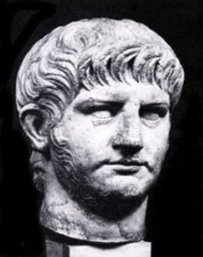

**Context**: Marcus Antonius Felix was the ancient Roman procurator of the Judaea Province from 52-60 AD. Felix’s cruelty and licentiousness, coupled with his accessibility to bribes, led to a great increase of crime in Judaea

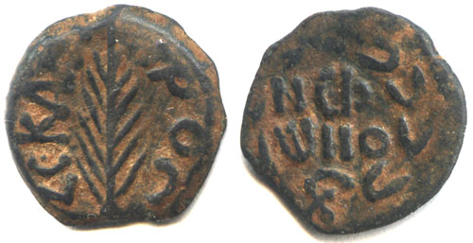

Felix coins

[*Feedback*](https://www.google.com/search?q=procurator+definition&oq=procurator&aqs=chrome.1.69i57j0l5.5511j1j8&sourceid=chrome&ie=UTF-8)

## Web results

### [**Procurator | Definition of Procurator by Merriam-Webster**](https://www.merriam-webster.com/dictionary/procurator)

https://www.merriam-webster.com/dictionary/procurator

**Definition** of **procurator**. 1 : one that manages another's affairs : agent. 2 : an officer of the Roman empire entrusted with management of the financial affairs of a province and often having administrative powers as agent of the emperor.

V35

Herod’s palace: Once the residence of Herod the great, now the headquarters of the Roman Governor.

[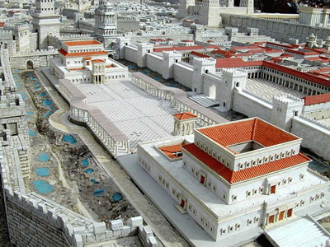](http://www.google.com/url?sa=i&rct=j&q=&esrc=s&frm=1&source=images&cd=&cad=rja&uact=8&ved=0CAcQjRxqFQoTCKub0ZHhpMcCFRUxiAodJi8BXg&url=http://www.goodnews.ie/herod.shtml&ei=6t7LVav-OJXioASm3oTwBQ&bvm=bv.99804247,d.cGU&psig=AFQjCNG7MEAi4l6e2Hm56gCBISG1rhDauA&ust=1439510633601765)

It is clear from the presence of the High Priest himself as the head of the delegation making the charges against Paul, that Claudius Lysias’ precaution of using 470+ soldiers to protect Paul was well founded.

Chapter 24

V1-5

V5

Now Christianity is being called a sect of the Nazarene. The word “sect” is the Greek word *haerisis*, translated into English would be heresy. What is the Jews basic argument? That Paul is teaching a heresy that is not allowed under Jewish and therefore Roman law.

V10-21

Paul’s defense? Paul makes the argument that he is actually fulfilling the law as a Jew who believes in the prophecies of the O.T.

V21

Where is the O.T. prophecy about the resurrection from the dead? Daniel 12:2

V24 -26

Drusilla was the daughter of Herod Agrippa I (Acts12:1 who died in AD 44) and sister of Herod Agrippa II. She had married King Aziz of Emesa but Felix had recently seduced her from him.

Is it any surprise then that Felix would fear the teachings about righteousness and also was waiting for a bribe? In the end, Felix never released Paul even though he had concluded that Paul was innocent. Thus was the state of affairs in Judea at the time - corruption at the highest levels. Felix was more content with comfort, pleasure, power and appearance than righteousness.

Chapter 25

V1

Porcius Festus was procurator from AD 58 or 59 to 61 or 62. He died in office.

All of the persons in this narrative can be read about in the writings of Josephus.

|  |  |
| --- | --- |
| **Josephus** | |
| [Josephus.jpg](https://en.wikipedia.org/wiki/File:Josephus.jpg)  The [romanticized](https://en.wikipedia.org/wiki/Romanticism) engraving of Flavius Josephus | |
| **Born** | Yosef ben Matityahu 37 CE [Jerusalem](https://en.wikipedia.org/wiki/Jerusalem), [Roman Judea](https://en.wikipedia.org/wiki/Judea_(Roman_province)) |
| **Died** | c. 100 CE (aged c. 63) |
| **Spouse(s)** | Captured Jewish woman Alexandrian Jewish woman Greek Jewish woman from Crete |
| **Children** | [Flavius Hyrcanus](https://en.wikipedia.org/wiki/Flavius_Hyrcanus) [Flavius Simonides Agrippa](https://en.wikipedia.org/wiki/Flavius_Simonides_Agrippa) [Flavius Justus](https://en.wikipedia.org/wiki/Flavius_Justus) |
|  |  |

**Titus Flavius Josephus** (37 – c. 100) born **Yosef ben Matityahu** was a first-century [Romano-Jewish](https://en.wikipedia.org/wiki/Roman_Jews) scholar and [historian](https://en.wikipedia.org/wiki/Historian) born in [Jerusalem](https://en.wikipedia.org/wiki/Jerusalem)—then part of [Roman Judea](https://en.wikipedia.org/wiki/Judea_(Roman_province))—to a father of [priestly](https://en.wikipedia.org/wiki/Jewish_priesthood) descent and a mother who claimed royal ancestry.

He initially fought against the Romans during the [First Jewish–Roman War](https://en.wikipedia.org/wiki/First_Jewish%E2%80%93Roman_War) as head of Jewish forces in [Galilee](https://en.wikipedia.org/wiki/Galilee), until surrendering in 67 CE to [Roman forces](https://en.wikipedia.org/wiki/Roman_army) led by Vespasian. Vespasian decided to keep Josephus as a slave and presumably interpreter. After Vespasian became Emperor in 69 CE, he granted Josephus his freedom, at which time Josephus assumed the emperor's family name of Flavius.

Flavius Josephus fully defected to the Roman side and was granted [Roman citizenship](https://en.wikipedia.org/wiki/Roman_citizenship). He became an advisor and friend of Vespasian's son [Titus](https://en.wikipedia.org/wiki/Titus) and when the siege of Jerusalem proved ineffective, it led to Jerusalem and the Temple’s destruction in 70 AD.

Josephus recorded [Jewish history](https://en.wikipedia.org/wiki/Jewish_history) in the first century AD and the First Jewish–Roman War (66-70 AD). His most important works were [*The Jewish War*](https://en.wikipedia.org/wiki/The_Jewish_War) (c. 75) and [*Antiquities of the Jews*](https://en.wikipedia.org/wiki/Antiquities_of_the_Jews)(c. 94). These works provide valuable insight into first century Judaism and the background of [Early Christianity](https://en.wikipedia.org/wiki/Early_Christianity).

Chapter 26

V10

I gave my voice against them.—Better, gave my vote. The words show that Paul, though a “young man,” may have been a member either of the Sanhedrin itself or of some tribunal with delegated authority. Theologians/scholars are not in agreement about whether Paul was acting as a recognized authority in the “vote” against the Christians. But it is obvious that Paul sought the authority of his own accord: Acts9:1-2.

V22-23

Paul’s defense: the full gospel message as prophesied in the O.T.

1. Messiah must suffer (Is 52:13-53:13)
2. First to rise from the dead (Ps 16:9-11)
3. Be a light of salvation to the Jews and Gentiles (Is 49:6, Ps 22:27)

V24-29

Despite the fact that Herod Agrippa II knew the message. He was not open.

V31-32

Herod Agrippa II also concluded that Paul was innocent of any crime.

Chapter 27

V1-3

V1-2

That we should sail - The use of the term "we" here shows that the author of this book, Luke, was with Paul. He had been his traveling companion, and though he had not been accused, yet it was resolved that he should still accompany him. Whether he went at his own expense, or whether he was sent at the expense of the Roman government, does not appear.

Into Italy - The country still bearing the same name, of which Rome was the capital.

And certain other prisoners - Who were probably also sent to Rome for a trial before the emperor. Dr. Nathaniel Lardner has proved that it was common to send prisoners from Judea and other provinces to Rome (Credibility, part i. chapter 10, section 10, pp. 248, 249).

A centurion - A commander of 100 men.

Of Augustus' cohort: a cohort-was a division in the Roman army consisting of from 400 to 600 men. This was called "Augustus' band" in honor of the Roman emperor Augustus, and was probably distinguished in some way for the care in enlisting or selecting them. The Augustine cohort or band is mentioned by Suetonius in his Life of Nero, 20. It was stationed in Syria during the 1st century A.D. It has been suggested that it was a “corp of officer-couriers” known as “frumentarii” in immediate service to the Emperor, of which transporting prisoners to see the Emperor would have been such a service.

V3

Aristarchus, a Macedonian from Thessalonica was already mentioned twice in Acts, at Ephesus (19:29) and in Macedonia (20:4), a close companion of Paul (Col4:10 and Philem24)

Julius clearly considered Paul a different type of prisoner.

This part of Acts is amazing for its specificity. It names harbors, winds, and navigational issues. It mentions the names of the travelers, the advice of the captain and owner of the ship and the advice that Paul gave.

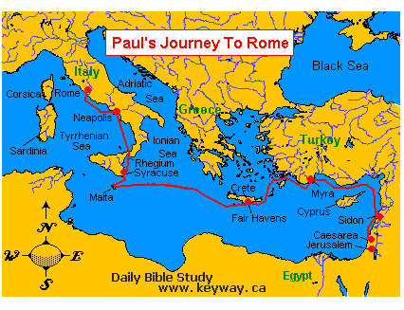

V14-20

Why were the sailors afraid of the Syrtis Sands? The Syrtis is two bodies of water in the Mediterranean Sea off the coast of North Africa. Even with “good luck” (Procopius’ words), the sailors on the Alexandrian grain ship carrying the Apostle Paul and Dr. Luke were terrified because they knew they were doomed if they hit the Syrtis Sands. The grain ships were the largest ships plying the Mediterranean Sea at that time, with a deep draft, and they would easily have gotten grounded on a sandbar in the middle of no-where and many miles from any shoreline! The old sailor’s axiom would hold true: “Water, water everywhere, but not a drop to drink!” They would have had plenty of grain to eat on the ship, but not a drop of water to go with it. They were afraid of a slow and painful death by dehydration.

Chapter 28

V7-10

Publius: Tradition says that this Publius became a Christian and ended up being the first bishop of the church in Malta. He was bishop there for 3o years and then went to Athens where he was martyred in 125A.D.

V22

Christianity once again is called a sect. The actual word is: [haireseōs](http://biblehub.com/greek/aireseo_s_139.htm)  
αἱρέσεως - choice, opinion

*haíresis* ("a strong, distinctive opinion") is used in the NT of individual "parties (sects)" that operated within Judaism. The term stresses the *personal aspect of choice* – and hence how being a Sadducee (Ac 5:17) was sharply distinguished from being a Pharisee (Ac 15:5; 26:5).

It seems strange that the Jews in Rome had so little knowledge of the events in Judaea. Already in the reign of Claudius, an edict had been issued “that all Jews should leave Rome.” (Acts18:2, AD 49-50) This was alluded to by “the instigation of Chrestus” from Seutonius in “Life of Claudius” (xxv. 4) (Roman historian c. 75-160), secretary to Emperor Hadrian. Since Paul was a Pharisee by training it was quite possible that the Jews in Rome gave Paul a hearing out of respect for his background.

References

Bruce, Frederick F. *The Acts of the Apostles: The Greek Text with Introduction and*

*Commentary.* London: Tyndale Press, 1965.

Bruce, Frederick F. *The New International Commentary on the New Testament: The Book of*

*the Acts,* Grand Rapids, MI: William Eerdmans Publishing Company, 1988.

Bruce, Frederick F. *The New International Commentary on the New Testament: The*

*Acts of the Apostles, Grand Rapids, MI: William Eerdmans Publishing Company, 1990.*

Translated by Libros Desafío: Hechos de los Apóstoles: Introducción, comentarios y

notas Título original en inglés. Copyright © 2007

Bruce, Frederick R. "Paul the Apostle", in The International Standard Bible Encyclopedia.

Vol. 3: K-P, ed. by. G. Bromiley (Eerdmans, 1995), pages 709-710.

<https://en.wikipedia.org/wiki/Ananias_son_of_Nedebeus>

https://www.jewishvirtuallibrary.org/pharisees-sadducees-and-essenes

Nyokabi, Joan. "The Differences Between The Pharisees and Sadducees." DifferenceBetween.net. April 8, 2016, http://www.differencebetween.net/miscellaneous/religion-miscellaneous/the-differences-between-the-pharisees-and-sadducees/.

1. https://books.google.com/books?id=mEKw2KckJ70C&pg=PA236&lpg=PA236&dq=Roman+Law+forbidding+beating+of+Romans+without+trial&source=bl&ots=pOh-1XVXlQ&sig=k67R-hT8Y\_q5qFskOTNankIuuHY&hl=en&sa=X&ved=2ahUKEwi9nfm5gvzdAhX0wMQHHReIADYQ6AEwDHoECAQQAQ#v=onepage&q=Roman%20Law%20forbidding%20beating%20of%20Romans%20without%20trial&f=false [↑](#footnote-ref-1)